**Spotlight on the Southend Team:**

Welcome to the Southend-on-Sea Integrated Service. In Southend we deliver seven health and wellbeing services:

* Tier 2 Adult Weight Management
* Health Trainer
* Falls Prevention
* Physical Activity
* Social Prescribing
* Workplace Wellbeing
* NHS Health Checks

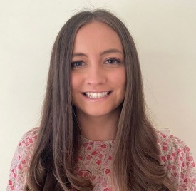

Amy Young - Service Manager:

“My role entails managing the team in Southend-on-Sea and co-ordinating the seven services to ensure each service meets it’s KPIs. I am a Registered Nutritionist with the Association for Nutrition specialising in Public Health. I also have experience in delivering both Child and Adult Weight Management working for EH over the past 3 years and 6 months. I enjoy partnership working, including project managing Social Prescribing on behalf of Southend Borough council.

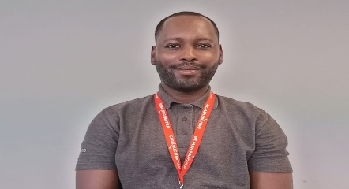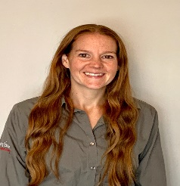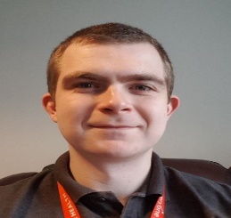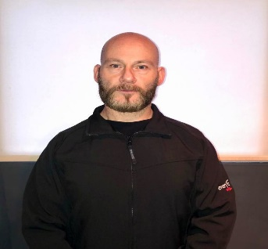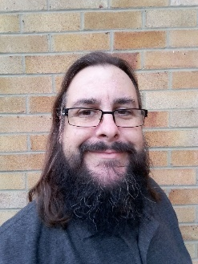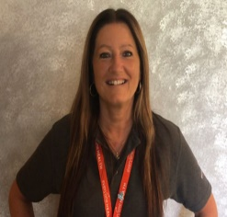

Susie Burt – NHS Health Check Co-Ordinator

Susie co-ordinates the NHS Health Checks contract. This service is on hold due to COVID, so Susie is supporting with the Southend COVID-response. She is also delivering MECC and RSPH training to support Workplaces. Susie has over 24 years working in South East Essex.

Martin Antonelli and Julie Zacharia – Health Trainers

Martin and Julie are our Health Trainers in Southend, who offer one to one support for helping people with behaviour changes. Julie has worked in the Health and Fitness industry for over 21 years. Martin has over 10 years’ experience as a health trainer. Together they have supported many during COVID working as a team.

Michael Rattigan – Postural Stability Instructor

Michael works on our Falls Prevention Service, offering a structured falls prevention physical activity programme for 36 weeks. Michael joined the Southend EH team via TUPE during COVID-19 and has over 27 years’ experience in the health and leisure industry.

Genesis Ali – Integrated Services Co-Ordinator / Nutritionist:

Genesis is a nutritionist and delivers our AWM programme. Genesis co-ordinates the Workplace Wellbeing Service ensuring businesses in Southend are healthy, by providing them with training such as Make Every Contact Count. He is our Social media champion and thrives with community engagement, supporting projects such as Social Prescribing.

Cameron Tonner – Physical Activity Specialist

Cameron delivers physical activity sessions for our AWM service. Cameron also delivers our physical activity service, offering those who do less than 30 minutes a week exercise the opportunity to get more active through his Facebook lives, Zoom classes and telephone support